How to Use Forms to Poll Participants in a Teams Meeting

Posted on [**December 15, 2020**](https://office365itpros.com/2020/12/15/use-forms-meeting-polls-teams/) by [**Tony Redmond**](https://office365itpros.com/author/thoughtsofanidlemind/)

Poll Meeting Participants During Calls

Announced at the [**Ignite 2020 conference**](https://techcommunity.microsoft.com/t5/microsoft-forms-blog/what-s-new-in-microsoft-forms-ignite-2020/ba-p/1680462) and subsequently in Office 365 notification MC225995 (November 6), the ability to use Forms to post and collect poll results during Teams meetings is now available to Office 365 tenants. [**Microsoft 365 roadmap item 68837**](https://www.microsoft.com/en-us/microsoft-365/roadmap?rtc=2&filters=&searchterms=68837) promises that this will deliver “*an easily discoverable and seamless experience that will help you conduct more engaging and productive meetings*.” The functionality to create and manage polls for meetings is available in Teams desktop and browser clients, but not yet in Teams mobile.

Using [**Forms to create surveys posted in a Teams channel**](https://practical365.com/blog/use-microsoft-forms-in-teams-to-work-together-managing-anonymous-surveys/) is well-known functionality. Using Forms to run polls in meetings is based on the work done to [**support apps in meetings**](https://docs.microsoft.com/en-us/microsoftteams/platform/apps-in-teams-meetings/teams-apps-in-meetings), where both first-party and third-party apps can be included as a meeting resource. Tenants who do not want to allow polls in meetings can [**block the Forms app through the Teams admin center**](https://office365itpros.com/2020/04/27/managing-teams-apps/).

Teams only supports polls for [**personal meetings**](https://office365itpros.com/2020/03/31/invitations-teams-meetings/). Polls currently aren’t supported for channel meetings or live events.

Add the Forms App to a Meeting

In the case of Forms-based polls, the basic approach is straightforward. After the meeting is created, the organizer adds the Forms app to the meeting. This creates a Polls tab in the list of meeting resources (Figure 1). The Polls tab is the entry point to create polls and view results.

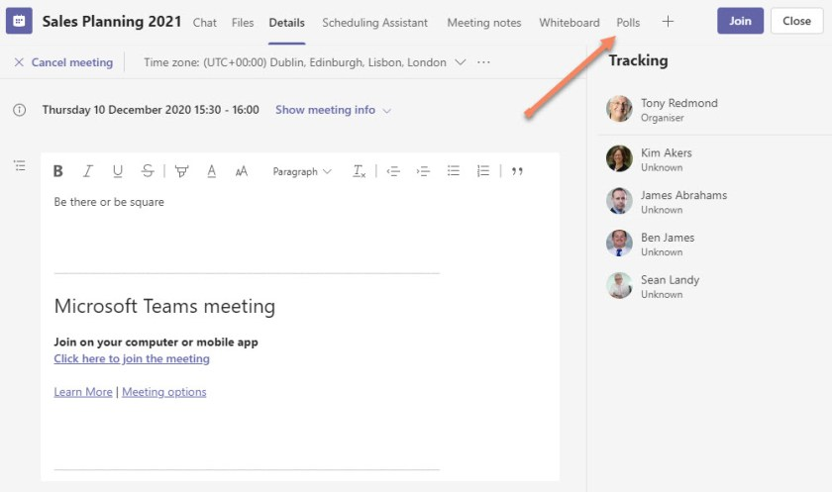Figure 1: The Polls tab is available after Forms is added to a Teams meeting

Creating and Running a Poll

Only those holding the organizer or presenter role for meetings can create polls (but only presenters from the tenant; guests who are presenters can’t create polls).

A poll is composed of a question and up to six precanned responses (Figure 2). Most polls are created up-front before the meeting begins, but ad-hoc polls can also be created during a meeting. For best results, it’s usually best to have done the up-front work to figure out the question to ask and suitable responses beforehand.

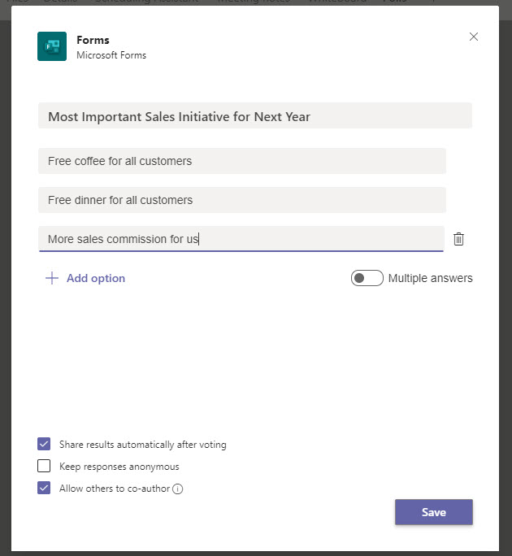Figure 2: Creating the questions for a Teams meeting poll

Once a poll is prepared, it can be published before the meeting to allow participants to respond before the meeting begins. In this case, the poll appears as a card in the meeting chat.

During the meeting, the organizer or presenters can publish polls at the point when it’s a good time to ask the question. Because the full meeting experience is available, Teams uses a pop-up notification displayed in the middle of the meeting window to display the poll card.

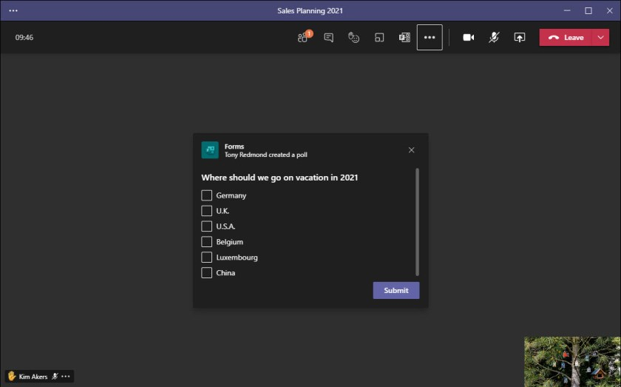Figure 3: Teams displays a pop-up notification to start a poll

Teams also displays the poll in a card in the meeting chat. Attendees can respond through the pop-up window or chat (Figure 4). Users of mobile devices and attendees from outside the tenant can’t see the pop-up window but can respond through chat.

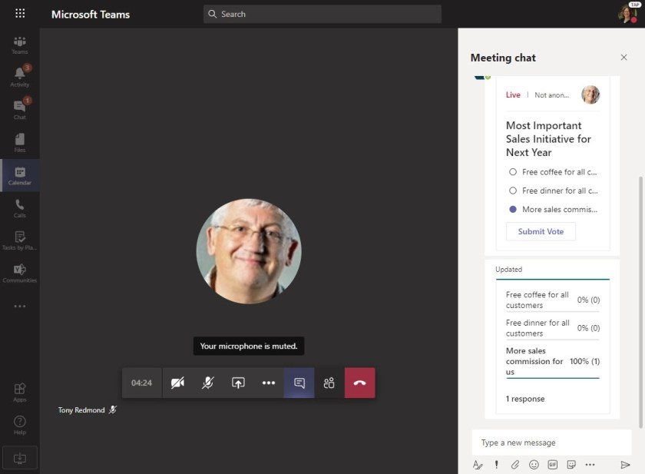Figure 4: Voting in a Teams poll through the card in the meeting chat

Depending on the poll setting can choose one or more of the available responses. Answers can be kept anonymous or user details can be logged with answer details, and if the poll is not anonymous, results can be viewed interactively as people respond.

When enough information is gathered, a **Live** poll can be closed off (Figure 5) and its results downloaded to an Excel worksheet. If necessary, a poll can be re-opened to gather more answers, such as from late-joining participants.

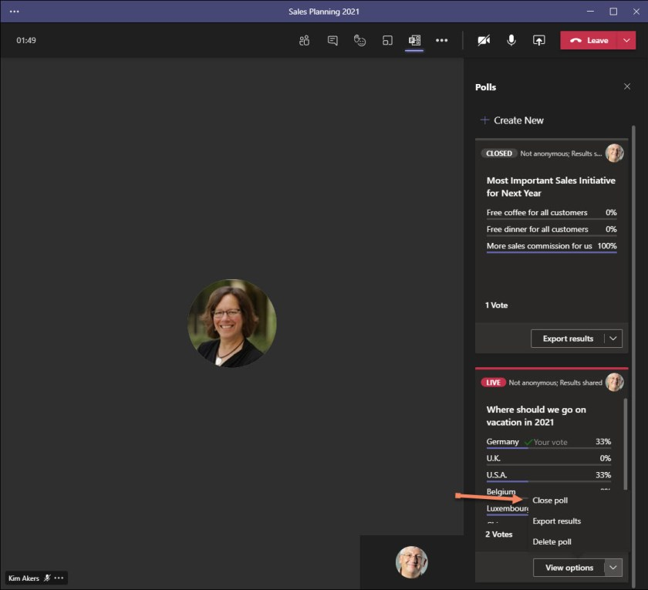Figure 5: Managing polls during a Teams meeting

After the meeting is over, the poll data remains available as one of the resources associated with the meeting, just like the meeting chat, whiteboard, files, or meeting notes. The form used for a poll is stored as a personal form in the creator’s account. You can use the Forms app (Figure 6) to view the form and the results gathered in a poll, but you can’t edit it there.

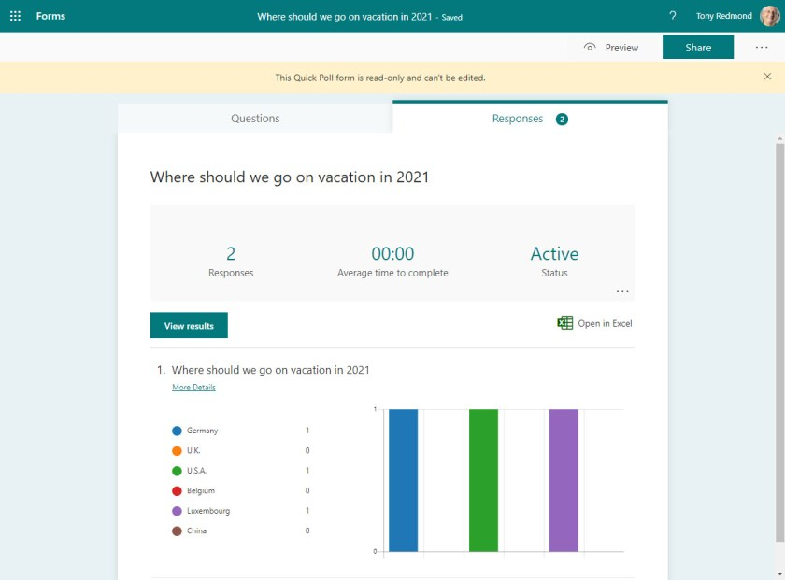Figure 6: A form used by a Teams meeting poll as viewed through the Forms app